Chapter 15

15.1 See diagrams in Figure 8.29
_______________________________________

15.2
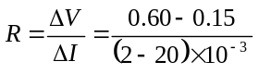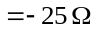
_______________________________________

15.3
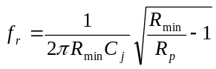
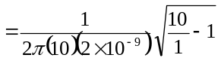
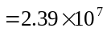Hz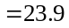MHz
_______________________________________

15.4
- 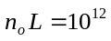cm
(i)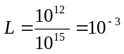cm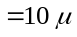m
(ii)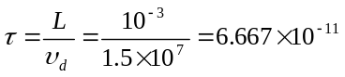s
(iii)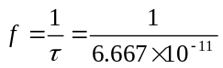
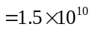Hz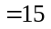GHz
(b)
(i)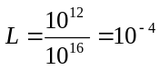cm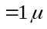m
(ii)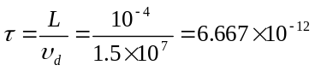s
(iii)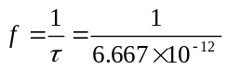
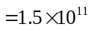Hz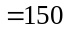GHz
_______________________________________

15.5
- 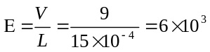V/cm
- 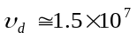cm/s
- 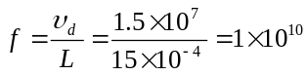Hz
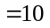GHz
_______________________________________
15.6
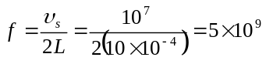Hz
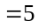GHz
_______________________________________

15.7
- 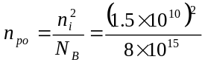
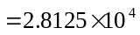cm
(i)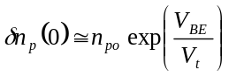
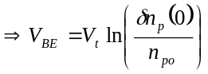
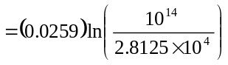
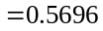V
(ii) Neglecting any recombination in the base
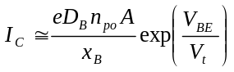
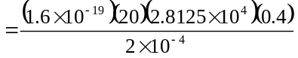
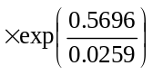
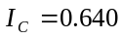A
- 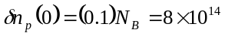cm
(i)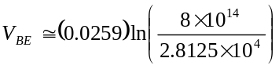
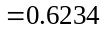V
(ii)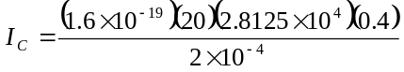
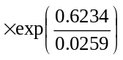
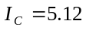A
_______________________________________

15.8
- From Figure 7.15, 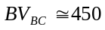V
- 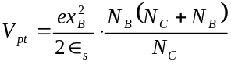
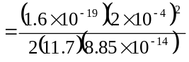
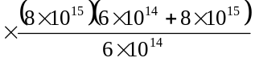
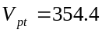V

- From Figure 7.15, 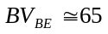V
_______________________________________

15.9
From the junction breakdown curve, for
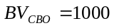V, we need the collector doping
concentration to be 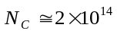cm.

Depletion width into the base (neglect 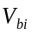).
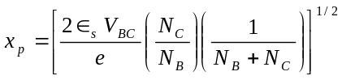
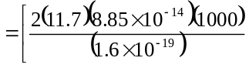
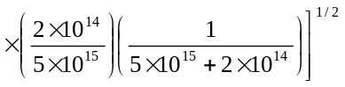
or
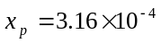cm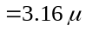m
(Minimum base width)
Depletion width into the collector
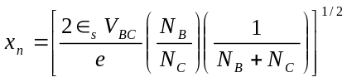
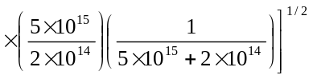
or
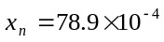cm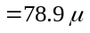m
(Minimum collector width)
_______________________________________

15.10
- 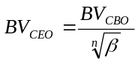
(i)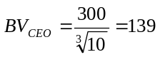V
(ii)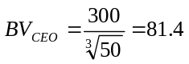V
(b)
(i)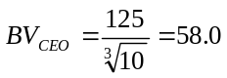V
(ii)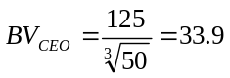V
_______________________________________

15.11
(a) We have
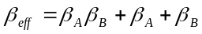
so
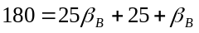
or
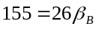
which yields
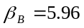
(b) We have
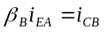
or
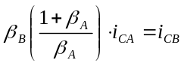
so
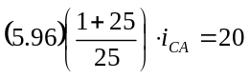
which yields
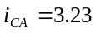A
_______________________________________

15.12
- 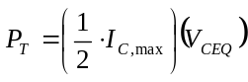
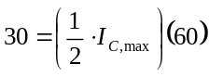
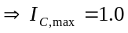A
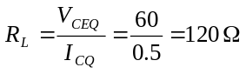
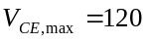V

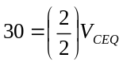
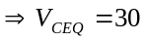V
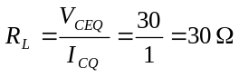
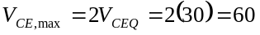V
- Same as part (b)
_______________________________________

15.13
- 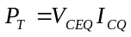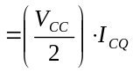
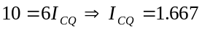A
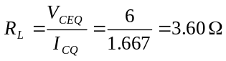
- 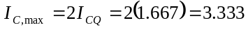A
_______________________________________

15.14
If 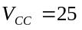V, then
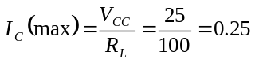A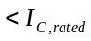
The power
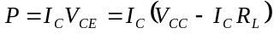
Now, to find the maximum power point
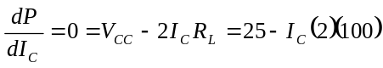
which yields
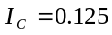A
So
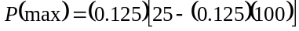
or
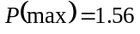W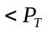
So maximum 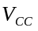 is V
_______________________________________

15.15
Now 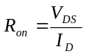
Power dissipated in the transistor
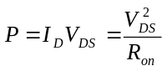

We have
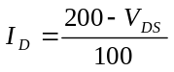
so we can write
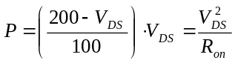
For 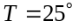C, 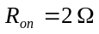.
Then
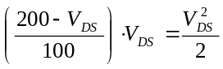
which yields
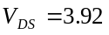V
The power is
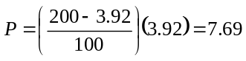W
We then have
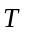(C) | 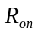() | 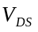(V) | 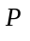(W)
25  50  75  100 | 2.0  2.33  2.67  3.0 | 3.92  4.56  5.19  5.83 | 7.69  8.91  10.1  11.3
_______________________________________

15.16
(a) We have, for three devices in parallel,
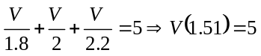
or
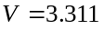V
Then, 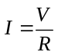, so that
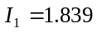A
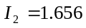A
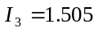A
Now, 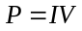, so
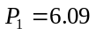W
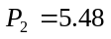W
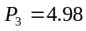W
(b) Now
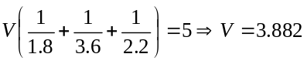V
Then
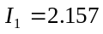A, 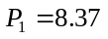W
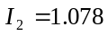A, 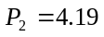W
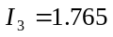A, 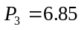W
_______________________________________

15.17
- Let the n-drift region doping
concentration be 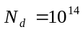cm.
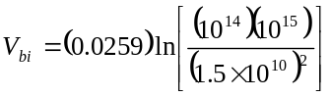
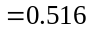V
For the base region,
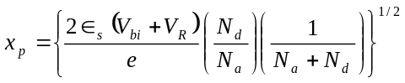
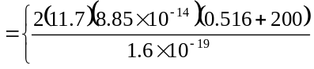
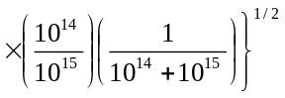
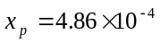cm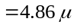m
= channel length

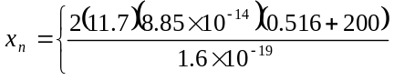
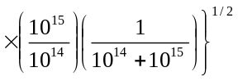
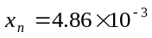cm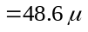m
= drift region width
- Assume cm
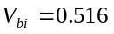V
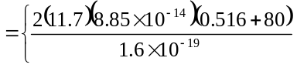
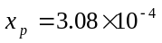cm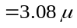m
= channel length
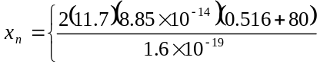
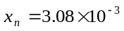cm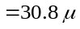m
= drift region width
_______________________________________

15.18
(b) In the saturation region,
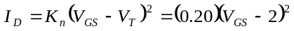
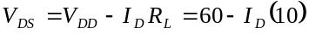
For 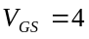V, 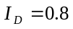A, 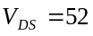 V
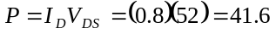W
For 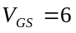V, 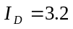A, 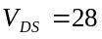V
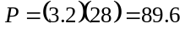W
For 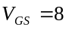V, transistor biased in the
nonsaturation region.
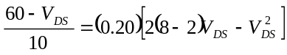
We obtain 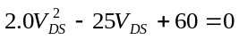
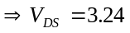V, 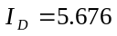A
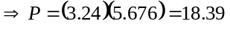W
For V, 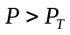 so transistor may
be damaged.
_____________________________________

15.19
- 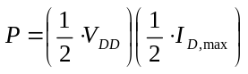
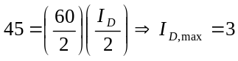A
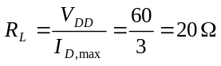
- 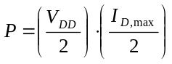
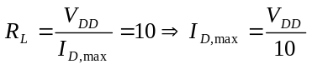
Then
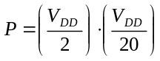
Or
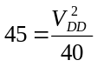
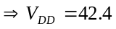V
_______________________________________

15.20
We have 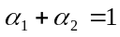. Now
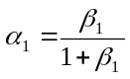 and 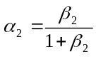
so
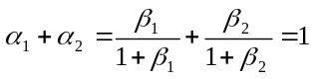
which can be written as
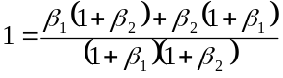
or
Expanding, we find
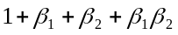
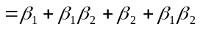
which yields
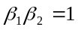
_______________________________________

15.21
The reverse-biased p-well to substrate junction corresponds to the 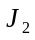 junction in an SCR. The photocurrent generated in this junction will be similar to the avalanche generated current in an SCR, which can trigger the device.
_______________________________________

15.22
Case 1: Terminal 1(+), terminal 2(-), and 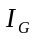 negative: this triggering was discussed in the text.

Case 2: Terminal 1(+), terminal 2(-), and positive: the gate current enters the P2 region directly so that J3 becomes forward biased. Electrons are injected from N2 and diffuse into N1, lowering the potential of N1. The junction J2 becomes more forward biased, and the increased current triggers the SCR so that P2N1P1N4 turns on.

Case 3: Terminal 1(-), terminal 2(+), and positive: the gate current enters the P2 region directly so that the J3 junction becomes more forward biased. More electrons are injected from N2 into N1 so that J1 also becomes more forward biased. The increased current triggers the P1N1P2N2 device into its conducting state.

Case 4: Terminal 1(-), terminal 2(+), and negative: in this case, the J4 junction becomes forward biased. Electrons are injected from N3 and diffuse into N1. The potential of N1 is lowered which increases the forward biased potential of J1. This increased current then triggers the P1N1P2N2 device into its conducting state.
_______________________________________

